AAC CIL Plant: Integrated Monitoring Solution Proposal
Prepared by Smart Innovations GH for Accountable Africa Capital · Sep 27, 2026 · @SVondee

Executive summary
We recommend one integrated "Mine-to-Mill" monitoring platform that tracks every excavator, litre of fuel, tonne of tailings and truck load from each concession to the AAC CIL plant. Today these are four separate blind spots; together they decide whether AAC's plant is fed at the volume and grade its investment case assumes.
The platform has four modules on one data backbone:
- Excavator Watch: telematics and geofencing that confirm each lent excavator works only inside its concession's permitted boundary.
- Fuel Intelligence: tank sensors and controlled dispensing that reconcile every litre issued against engine hours and tonnes moved.
- Tailings Twin: bi-weekly drone surveys, calibrated to a geologist baseline, that measure tailings volume, tonnage and estimated contained gold per concession.
- Haul Trace: GPS-tracked dump trucks with digital waybills and plant weighbridge checks, closing the loop between what leaves a concession and what reaches the plant.
The headline business impact is a daily mass balance: tailings measured on site = tonnes loaded = tonnes hauled = tonnes received at the plant. Any gap is flagged within hours, not discovered at month-end. Indicative targets, to be confirmed in the pilot, are a 10 to 20% cut in fuel cost, 15 to 25% higher excavator utilisation, and near-zero unaccounted truck loads.

Context and objectives
AAC's CIL plant depends on tailings (ore waste) sourced from 4 to 10 partner concessions, worked with excavators AAC has lent to the concession holders. AAC carries the asset, fuel and feed risk but has little real-time view of what happens on each concession.
Control gap | Risk to AAC | Objective
Excavator use | Machines used outside permitted areas, on third-party jobs, or idle | Prove every operating hour is inside the geotagged permit boundary
Excavator fuel | Diesel theft, siphoning, over-claiming, excessive idling | Account for every litre against work done
Tailings stock | Plant feed plan built on unverified volumes and grades | Measure tailings tonnage and grade bi-weekly, per concession
Truck haulage | Loads diverted, short-loaded, or trips inflated | Trace every load from concession pit to plant weighbridge
A secondary objective is compliance: geotagged evidence that AAC-funded activity stays within licensed boundaries supports reporting to the Minerals Commission, the EPA and investors.

Solution architecture
All four solutions share one backbone, so AAC buys and runs one platform rather than four disconnected tools.
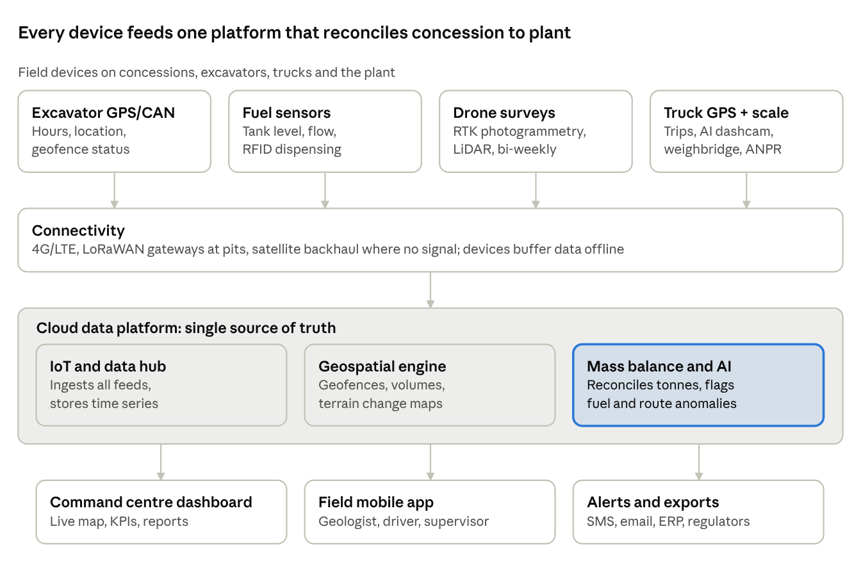
solution architecture · 4 field feeds, 1 platform, 3 outputs
Field devices send data over whatever signal each concession has, and buffer it when offline. The cloud platform joins the feeds by concession, machine and time, which is what makes cross-checks possible: fuel against engine hours, truck tonnes against drone-measured stockpile loss.
Recommended stack: OEM telematics via the ISO 15143-3 (AEMP 2.0) standard where the excavators support it, retrofit GPS/CAN trackers where they do not; a cloud IoT hub (AWS IoT or Azure IoT); a PostGIS geospatial database; drone processing in Pix4D, DroneDeploy or Propeller; and Power BI or a custom web dashboard. Open standards keep AAC free to switch vendors.

Solution 1: Excavator Watch (utilisation and geofenced permits)
Every lent excavator carries a tamper-proof tracker, and each concession's permit boundary becomes a digital geofence. AAC sees in real time where each machine is, whether it is working, idling or off, and whether it is inside its licensed area.
How it works
- Digital permit register. Each concession's permit polygon (from Minerals Commission coordinates or a GNSS survey of its pillars) is loaded as a geofence, linked to the permit number, holder and expiry date.
- Telematics. OEM telematics (for example Cat Product Link, Komatsu Komtrax) pulled via the AEMP 2.0 API, or a retrofit GPS/CAN tracker with backup battery and tamper alarm on older machines.
- Work-state detection. Engine hours, RPM and hydraulic pressure or an IMU classify each hour as digging, tramming, idling or off. An optional bucket-cycle counter estimates loads per shift.
- Rules and alerts. Instant SMS and app alerts for geofence exit, out-of-hours use, tracker power cut, or permit nearing expiry. An engine immobiliser relay can block starting outside the permitted zone or schedule.
- Predictive maintenance. Fault codes and hour meters drive service schedules and early warnings of breakdowns.
Benefit | Business impact
Proof each machine works only inside a valid permit | Protects AAC from reputational and legal exposure to illegal mining; supports ESG and investor reporting
True utilisation per machine and concession | Redeploy idle excavators to productive concessions; indicative 15 to 25% higher utilisation
Theft and misuse deterrence | Protects capital assets worth hundreds of thousands of dollars each; lowers insurance risk
Hours-based usage data | Fair, evidence-based lease or cost-recovery billing to concession holders
Predictive maintenance | Fewer breakdowns and less downtime; longer machine life

Solution 2: Fuel Intelligence (excavator fuel usage)
Every litre is measured three times: when it leaves the bowser or tank, when it enters the machine, and as the engine burns it. Any mismatch between the three is flagged automatically.
How it works
- Controlled dispensing. Smart fuel bowsers or site tanks with flow meters release fuel only against an RFID tag on the machine and an operator ID card, recording litres, time and GPS position.
- In-tank sensors. Capacitive fuel-level sensors in each excavator tank detect refuels and sudden drops (siphoning) to within about 1% of tank volume.
- Engine burn data. CAN-bus fuel-rate data, or a flow meter on older engines, gives actual consumption per engine hour.
- Efficiency KPIs. Litres per engine hour, litres per tonne of tailings moved, and idle-burn percentage, benchmarked across machines and concessions.
- AI anomaly detection. Models learn each machine's normal burn and flag outliers such as a refuel with no level rise, level drops while the engine is off, or burn far above peers.
Benefit | Business impact
Every litre accounted for, from tank to engine | Diesel is typically among the largest mining operating costs; indicative 10 to 20% saving from theft and waste reduction
Idle-time visibility | Operator coaching and auto-shutdown policies cut idle burn
Litres per tonne KPI | Links fuel spend directly to feed delivered, so AAC pays for productive work
Audit-ready fuel records | Evidence for fuel cost recovery from concession holders and for carbon (Scope 1) reporting

Solution 3: Tailings Twin (bi-weekly volumetrics per concession)
A drone flies each concession every two weeks and builds a centimetre-accurate 3D model of its tailings. Comparing each model with the last one, and calibrating it to the geologist's baseline, gives tonnes and estimated gold content per concession, bi-weekly.
The bi-weekly cycle
- Baseline (once, then yearly). A geologist surveys each concession: tailings footprint, test pits or auger holes, bulk density and gold grade assays. A first drone flight with fixed ground control points (GCPs) records the starting surface.
- Fly (every 14 days). An RTK/PPK drone (for example DJI Matrice 4E, or a LiDAR payload where vegetation hides the ground) flies a pre-set mission. About 1 to 2 hours per concession.
- Process (within 24 to 48 hours). Photogrammetry produces an orthomosaic and digital surface model, accurate to about 2 to 5 cm with GCPs.
- Measure. Stockpile volumes and a cut-and-fill map show material added, removed or moved since the last flight.
- Convert and reconcile. Volume becomes tonnes and estimated contained gold using the geologist's density and grade, then is checked against truck tonnes hauled to the plant.
\text{Tonnes} = \text{Volume (m}^3) \times \text{Bulk density (t/m}^3) \qquad \text{Contained Au (oz)} = \frac{\text{Tonnes} \times \text{Grade (g/t)}}{31.1035}
- AI change detection. Models trained on the imagery flag new pits, encroachment beyond the permit, water ponding or unstable slopes.
- Satellite gap-filling. Low-cost satellite imagery (Sentinel-2 free, or Planet daily imagery) watches for major changes between flights.
- Grade model updates. Plant assay results feed back to refine each concession's grade estimate over time.
Benefit | Business impact
Verified tonnage and grade per concession, every 2 weeks | Plant feed planning and gold production forecasts rest on measured, not declared, stock
Depletion trend per concession | Early warning to secure new concessions before feed runs short; protects plant throughput
Reconciliation with haulage | Exposes tailings leaving a concession without reaching the plant
Fair, evidence-based payments | Pay concession holders on measured tonnes and grade; fewer disputes
Environmental and slope monitoring | Supports EPA compliance, reclamation planning and site safety
Bankable data record | Strengthens AAC's case with lenders and investors

Solution 4: Haul Trace (dump truck geotagging and chain of custody)
Every truck round trip, from the CIL plant out to the concession and back, becomes a digital, geotagged record from loading at the pit to tipping at the plant. A load that stops off-route, arrives light, or never arrives is flagged in real time.
How it works
- GPS trackers on every truck, reporting every 10 to 30 seconds, with approved haul routes and stop zones set as geofences.
- Digital waybill. At loading, the supervisor's app creates an e-waybill with a QR code or RFID seal: truck, concession, time, GPS point, excavator and bucket count.
- Plant gate check. An automatic number-plate recognition (ANPR) camera and the weighbridge match each arriving truck to its waybill and record net tonnes. Optional on-board load sensors weigh at the pit too.
- AI dashcams. Road-facing and driver-facing cameras record events and detect fatigue, phone use and speeding.
- Trip analytics. Cycle time, queue time at pit and plant, trips per truck per day, and route deviations.
Benefit | Business impact
Unbroken chain of custody from pit to plant | Stops diversion of gold-bearing tailings; near-zero unaccounted loads
Weighbridge tonnes matched to loading records | Pay haulage contractors per verified tonne, not per claimed trip
Cycle-time and queue analytics | Better truck dispatch; more tonnes delivered with the same fleet
Driver safety monitoring | Fewer accidents on community roads; lower insurance and liability costs
Geotagged trip history | Evidence for regulators and communities on haul routes and timings

Command centre, AI analytics and reporting
One dashboard, on a wall screen at the plant and on phones, shows all concessions on a live map with the four modules layered on top.
- Live map: every excavator and truck, permit geofences, the latest drone orthomosaic per concession.
- Daily mass balance: tonnes measured on site, loaded, hauled and received at the weighbridge, with the gap at each step.
- Concession scorecard: tonnes delivered, grade, fuel per tonne, machine utilisation and alerts, ranked across all 4 to 10 concessions.
- Bi-weekly tailings report: auto-generated PDF per concession with volume change, tonnage, estimated gold and depletion forecast.
- AI assistant: managers ask plain-language questions such as "Which concession had the highest fuel per tonne this month?" and get answers from the data.
- Integrations: export to AAC's accounting or ERP for payments to concession holders and haulers; role-based access for AAC, concession holders, geologists and auditors.

Implementation roadmap
We propose a phased rollout: a 3-month pilot on two concessions proves value before AAC commits to the full fleet.
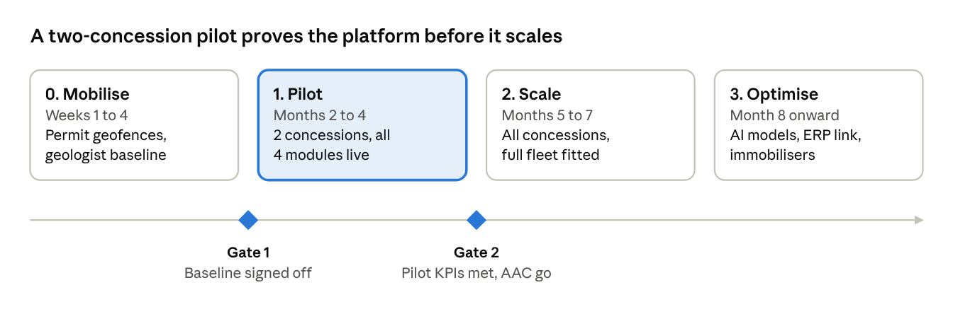
implementation roadmap · 4 phases, 2 gates
The pilot runs all four modules end to end, so the Gate 2 decision rests on a real mass balance, not a demo. Pilot KPIs are agreed with AAC in Phase 0.

Who: delivery team and responsibilities
Smart Innovations GH leads delivery as prime contractor. We bring in specialist partners for geology, surveying, drones and hardware. AAC provides a sponsor, an owner and access. Effort figures are indicative for a pilot of 2 concessions, scaling to 10.
Role | Provided by | Responsibility | Indicative effort
Executive sponsor | AAC | Approves budget and scope; chairs Gate 1 and Gate 2 | 2 hours a month
Project owner (operations) | AAC | Day-to-day decisions, site access, links to concession holders | 20%
Programme manager | Smart Innovations GH | Plan, budget, risks, vendors, reporting | 100%
Solution architect / IoT lead | Smart Innovations GH | Architecture, device selection, integrations, security | 100% in build, 50% after
Software team: 2 full-stack developers, 1 GIS/data engineer | Smart Innovations GH | Platform, dashboard, mobile app, geofences, mass balance | 100% in build
Data scientist / ML engineer | Smart Innovations GH | Fuel anomaly models, drone change detection, forecasts | 50% from pilot
Field installation technicians (2 to 3) | Smart Innovations GH or telematics partner | Fit trackers, fuel sensors, dashcams, gateways; maintain devices | Full-time during installs
Consulting geologist | Independent partner | Baseline sampling, bulk density, grade; signs off Gate 1 | About 3 weeks, then quarterly
Licensed surveyor | Partner | GNSS survey of permit pillars and ground control points | About 1 week per 2 concessions
Drone pilots (1 to 2), GCAA-certified | Partner or Smart Innovations GH | Bi-weekly flights and data upload | 1 to 2 days per concession a fortnight
Hardware vendors | Telematics, fuel and camera suppliers | Supply, warranty, spares | As needed
Connectivity providers | Mobile network and satellite provider | SIMs, data plans, satellite terminals | As needed
Concession site supervisors | Each concession holder | Create e-waybills at loading, allow site access, report faults | Part of daily routine
Haulage contractors and drivers | Hauliers | Keep trackers powered, follow approved routes | Part of daily routine
Weighbridge operator | AAC plant | Confirm arrivals against e-waybills | Part of daily routine
Legal and compliance | AAC legal, with our support | Monitoring clauses in lending and haulage contracts, data protection | About 2 weeks at start

What: hardware, software, data and approvals
The longest lead items are imported hardware (4 to 6 weeks) and drone flight approvals, so both are ordered in week 1. Pilot quantities cover 2 concessions; scale quantities follow the same basis.
Hardware
Item | Quantity basis | Provided by | Needed by
GPS/CAN tracker with tamper alarm and optional immobiliser | 1 per excavator (if no OEM telematics) | Smart Innovations GH via vendor | Pilot install, week 3 of Phase 1
Capacitive fuel-level sensor | 1 per excavator | Smart Innovations GH via vendor | Pilot install
Smart fuel dispenser: flow meter, RFID reader, tags, operator cards | 1 per fuel point or bowser | Smart Innovations GH via vendor | Pilot install
Truck GPS tracker and AI dashcam | 1 per dump truck | Smart Innovations GH via vendor | Pilot install
QR or RFID load seals | 1 per load, consumable | Smart Innovations GH | Pilot go-live
ANPR camera and weighbridge software link | 1 set at plant gate | Smart Innovations GH; weighbridge assumed existing at AAC | Pilot go-live
4G/LoRaWAN gateway and satellite terminal, with solar power | 1 per concession without reliable signal | Smart Innovations GH via providers | Pilot install
RTK drone, GNSS base station, ground control markers | 1 kit for pilot, 2 kits at scale | Drone partner or Smart Innovations GH | Baseline flight, Phase 0
Rugged phones or tablets | 1 per concession supervisor, plus plant | AAC (or leased through us) | Pilot go-live
Command centre screen and PC | 1 at plant or AAC office | AAC | Pilot go-live
Software and services
- Cloud platform subscription (IoT hub, database, hosting), in AAC's name so AAC owns the data.
- Drone processing licence (Pix4D, DroneDeploy or Propeller).
- Dashboard and BI licences for AAC users; SMS and email gateway for alerts.
- SIM data plans and satellite airtime.
- Support and maintenance contract after go-live.
Data and access AAC must provide (by end of Phase 0 week 2)
- Permit coordinates, licence numbers and expiry dates for every concession.
- Register of lent excavators and hauling trucks: make, model, serial or plate, year.
- Last 3 to 6 months of fuel issue records, weighbridge records and feed receipts, to set the "before" baseline.
- Any existing geology or assay reports for the concessions.
- Signed site access for our teams on each concession.
Approvals and agreements
- Monitoring and data-sharing clauses added to excavator lending and haulage contracts.
- Drone and pilot registration and flight permissions from the Ghana Civil Aviation Authority.
- Registration with Ghana's Data Protection Commission and driver consent, because dashcams capture personal data.
- Concession holder consent to bi-weekly survey flights.

When: delivery timeline
If the contract is signed by 30 October 2026, the pilot starts on 7 December 2026, AAC decides at Gate 2 on 5 March 2027, and the full fleet goes live on 28 May 2027.
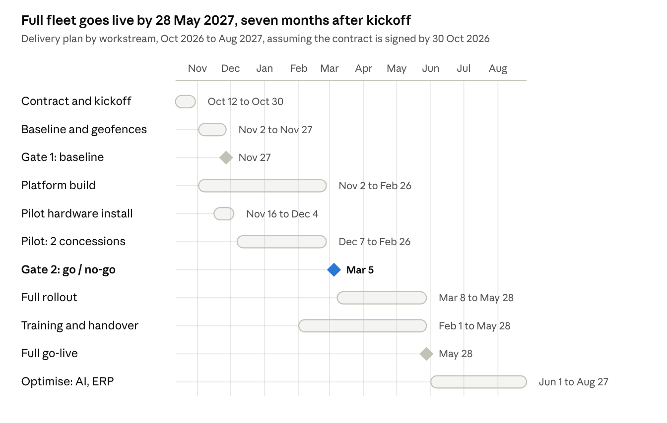
delivery timeline · 11 workstreams and milestones, Oct 2026 to Aug 2027
The pilot runs over the Christmas and New Year period, when site activity is lower. We keep it at 12 weeks so it still captures at least 5 bi-weekly drone cycles at normal activity. Every week the contract slips moves all dates by a week.

Phase-by-phase activity plan
Each phase ends with a clear deliverable, and the next phase starts only when its exit criteria are met.
Phase and dates | Key activities | Lead | Deliverables | Exit criteria
Pre-start: contract (12 to 30 Oct 2026) | Agree scope, budget and pilot concessions; amend lending and haulage contracts; order long-lead hardware; start drone permits | AAC sponsor, Smart Innovations GH programme manager | Signed contract, purchase orders, project charter | Contract signed; AAC data request issued
Phase 0: Mobilise (2 to 27 Nov 2026) | Kickoff; collect permit, fleet, fuel and weighbridge data; survey permit pillars; geologist sampling; baseline drone flights; detailed design | Programme manager, geologist, surveyor | Digital permit register, baseline tonnage and grade per pilot concession, solution design, pilot KPIs | Gate 1: geologist signs off baseline; AAC approves design and KPIs
Phase 1: Pilot (16 Nov 2026 to 26 Feb 2027) | Install devices on pilot excavators, trucks and fuel points; launch dashboard and mobile app; run 6 bi-weekly drone cycles; train pilot users; tune alerts | Solution architect, field technicians, drone pilots | Live platform for 2 concessions, bi-weekly tailings reports, first mass balance, pilot results report | Gate 2 (5 Mar 2027): pilot KPIs met; AAC approves scale budget
Phase 2: Scale (8 Mar to 28 May 2027) | Order and fit hardware for remaining concessions; add their geofences and baselines; train all supervisors, drivers and plant staff; set up support desk | Programme manager, field technicians | All 4 to 10 concessions live; trained users; support process | Full fleet reporting daily for 2 weeks; AAC acceptance sign-off
Phase 3: Optimise (from 1 Jun 2027) | Train AI models on full data; link to ERP for payments; enable immobilisers; forecast depletion; quarterly baseline refresh | Data scientist, solution architect | Anomaly and forecast models, ERP integration, quarterly business review | Ongoing, measured against KPI targets

Governance and cadence
The steering committee meets every two weeks, timed to each bi-weekly tailings report, so decisions follow the newest data.
Forum | Frequency | Attendees | Purpose
Project stand-up | Weekly | Programme manager, AAC project owner, workstream leads | Progress, blockers, next week's plan
Steering committee | Bi-weekly | AAC sponsor, AAC project owner, Smart Innovations GH lead | Review tailings report, KPIs, risks; approve changes
Gate review | Gate 1 and Gate 2 | Steering committee plus consulting geologist | Go or no-go on the next phase and its budget
Concession holder forum | Monthly | AAC, concession holders, hauliers | Share scorecards, resolve disputes, build buy-in
Quarterly business review | Quarterly, from Phase 3 | AAC leadership, Smart Innovations GH | ROI against targets, roadmap updates

Business impact summary and KPIs
The platform turns AAC from a passive funder into an operator with verified control of its feed supply chain. Targets below are indicative and will be baselined in Phase 0 and confirmed in the pilot.
Module | Key KPI | Indicative target | Primary business impact
Excavator Watch | Productive hours per machine; geofence breaches | +15 to 25% utilisation; zero unapproved out-of-permit hours | Asset protection, licence compliance, fair cost recovery
Fuel Intelligence | Litres per tonne; unexplained fuel loss | 10 to 20% lower fuel cost; loss under 2% | Direct operating cost saving
Tailings Twin | Tonnage and grade variance vs plant receipts | Variance within about 5% | Reliable feed plan and gold production forecast
Haul Trace | Loads traced pit to plant; cycle time | 100% of loads traced; shorter cycle times | Stops feed leakage, pays haulers per verified tonne
Platform | Time to detect a discrepancy | Hours, down from weeks | Faster decisions, stronger lender and investor confidence
The return comes mainly from fuel savings, recovered tailings that would otherwise leak, and higher plant throughput. For a CIL plant, even a small rise in gold recovered from correctly delivered feed typically outweighs the platform's running cost. A full ROI model will be built from AAC's fleet size, fuel spend and feed volumes in Phase 0.

Financial model: cost to deliver
For 8 concessions, delivery costs about $467,000 one-off plus $256,000 a year to run, or roughly $32,000 per concession per year. All figures are in USD, pre-tax and exclude VAT. They come from the workbook AAC_Monitoring_Financial_Model.xlsx, which recalculates when any input changes.
Unit prices are approximate market estimates, because a live price check wasn't possible. Replace them with vendor quotes before any pricing decision.
One-off cost line | USD | Basis
Hardware, landed (incl. 20% duty and shipping) | 156,420 | 16 excavators, 24 trucks, 9 fuel points, 5 gateway sites, 2 drone kits, ANPR
Installation | 7,520 | 94 devices at $80
Implementation team | 185,000 | Programme manager, architect, developers, GIS, data science, technicians, travel, legal
Geologist baselines, surveys, training | 76,000 | $9,500 per concession
Contingency (10%) | 42,494
Total one-off | 467,434

Annual running cost line | USD per year
Support team (engineer, technician, 0.5 data scientist, 0.25 account manager) | 88,500
Drone survey flights (26 per concession) | 83,200
Geologist quarterly refresh | 24,000
Hardware maintenance and replacement (12% of hardware) | 18,770
Cloud, SIM data, satellite airtime, software licences | 25,774
Load seals and QR tickets | 8,640
Overheads (3%) | 7,467
Total annual | 256,351
Drones and the support team make up two thirds of running cost, so drone cost per flight and support staffing matter more than sensor prices.

Revenue models
All three models pay off for both sides in the base case. They differ in who carries the upfront cash and the performance risk. NPVs cover Year 0 (implementation) plus 5 operating years, discounted at 15%.
- Model A: fixed-price project plus managed service. AAC pays the one-off cost plus a 25% margin, then an annual service fee at running cost plus 30%.
- Model B: Monitoring-as-a-Service subscription. Smart Innovations GH funds and owns the hardware. AAC pays a 15% onboarding fee, then monthly fees: $220 per excavator, $120 per truck, $3,500 per concession and $3,000 for the plant hub.
- Model C: gain-share. Delivery is at cost, the service fee carries a 5% margin, and Smart Innovations GH takes 20% of verified savings. Those savings are fuel, extra gold margin and haulage over-claims removed, about $751,000 a year in the base case.
Base case, 8 concessions | A: Fixed price + service | B: Subscription | C: Gain-share
Smart Innovations GH 5-year revenue | $2.33M | $2.36M | $2.65M
Smart Innovations GH NPV | $394k | $229k | $565k
Smart Innovations GH gross margin | 22% | 23% | 32%
Smart Innovations GH IRR / payback | Costs recovered upfront | 36% IRR, Year 3 | Costs recovered upfront
AAC cash needed in Year 0 | $668k | $115k | $550k
AAC NPV of net benefit | $1.29M | $1.45M | $1.12M
AAC payback | Year 2 | Year 1 | Year 1
AAC's full-year benefit is about $905,000. Most of it, $551,000, is margin on roughly 390 oz of extra gold from stopping tailings leakage. The rest comes from fuel savings ($164,000), better excavator use ($134,000), haulage over-claims removed ($36,000) and theft avoided ($20,000).
A fourth model is possible later but not included in the numbers: licensing the platform to other CIL plants and to concession holders who want their own dashboards.

Sensitivity analysis
For Smart Innovations GH, the biggest risks are the number of concessions and the price level, and they hit the subscription model hardest. For AAC, the case depends on how much tailings leakage the platform actually stops. Each row below moves one driver from its low to its high value while everything else stays at base. Figures are NPVs in $k.
Driver (low to high) | SIGH NPV, A | SIGH NPV, B | SIGH NPV, C | AAC NPV, Model A
Extra feed secured, 1% to 5% of feed | 394 to 394 | 229 to 229 | 311 to 818 | 21 to 2,557
Concessions, 4 to 10 | 283 to 444 | -114 to 416 | 292 to 701 | 225 to 1,844
Tailings grade, 0.8 to 1.6 g/t | 394 to 394 | 229 to 229 | 438 to 692 | 655 to 1,923
Gold price, $2,800 to $4,200/oz | 394 to 394 | 229 to 229 | 489 to 641 | 909 to 1,669
Pricing level, 0.8x to 1.2x | 315 to 473 | -81 to 538 | 452 to 678 | 1,368 to 1,210
Running cost, 0.85x to 1.25x | 352 to 463 | 367 to -2 | 558 to 576 | 1,469 to 989
Excavator fuel saving, 6% to 18% | 394 to 394 | 229 to 229 | 517 to 612 | 1,050 to 1,528
Discount rate, 12% to 20% | 413 to 366 | 277 to 159 | 606 to 506 | 1,430 to 1,086
Hardware cost, 0.8x to 1.3x | 381 to 413 | 272 to 164 | 564 to 566 | 1,350 to 1,197
The workbook's Sensitivity sheet has the same view of AAC's NPV under Models B and C.
Scenario (all drivers together), $k | SIGH A | SIGH B | SIGH C | AAC A | AAC B | AAC C
Bear: 5 concessions, costs +15 to 20%, gold $3,000, 1.5% feed secured, 1.0 g/t | 345 | -208 | 177 | -617 | -64 | -449
Base | 394 | 229 | 565 | 1,289 | 1,454 | 1,118
Bull: 10 concessions, gold $4,000, 4% feed secured, 1.4 g/t | 431 | 552 | 1,172 | 4,299 | 4,177 | 3,557
Break-even points (base case)
- Model B: subscription fees can fall to 0.85x the base price list before Smart Innovations GH's NPV reaches zero. Below 6 concessions, Model B loses money at the base prices.
- Model C: a gain share of 13.4% gives Smart Innovations GH the same NPV as Model A. Every point above that is paid for carrying the performance risk.
- AAC: the platform pays for itself under Model A once it secures about 1.0% more feed than today. That makes a leakage estimate the pilot's most important measurement.
What each model means for each side
- Model A gives Smart Innovations GH a steady $345k to $431k NPV in every scenario, but asks AAC for $668k upfront.
- Model B is the lightest on AAC's cash and gives AAC the best base-case NPV. Smart Innovations GH carries the hardware and scale risk, and it is the only model that loses money for us in the bear case.
- Model C has the most upside for Smart Innovations GH and ties our pay to AAC's results. It needs trusted, audited savings data, which the mass balance provides.
Recommended pricing approach: price the pilot under Model A, so the pilot cost is fixed and neither side takes a bet before the data exists. At Gate 2, offer AAC a choice. Model B suits AAC if it wants low upfront cash, as long as the rollout is at least 6 concessions. Model C suits AAC if it prefers pay-for-results, with a gain share of 15 to 20% and an agreed method for verifying savings.

Risks, mitigations and next steps
Risk | Mitigation
No mobile signal on remote concessions | Devices store and forward; LoRaWAN or satellite gateways at pits
Tracker tampering or removal | Hidden installation, backup battery, tamper and power-cut alerts, immobiliser option
Resistance from concession holders or operators | Include monitoring clauses in excavator lending agreements; share dashboards with holders so data works for them too
Drone flight approval and weather | Register drones and pilots with the Ghana Civil Aviation Authority; schedule flights with a 3-day weather buffer
Poor baseline data skews tonnage | Independent geologist sign-off at Gate 1; recalibrate density and grade against plant assays
Data security and ownership | Role-based access, encrypted data, AAC owns all data under the contract
Next steps
- ☐ Confirm the number of concessions, excavators and trucks for the pilot and full scale
- ☐ Share permit coordinates and excavator makes and models, so we can check OEM telematics compatibility
- ☐ Agree pilot KPIs and the two pilot concessions
- ☐ Smart Innovations GH to return a costed proposal and ROI model

